SIMATS ENGINEERING (SAVEETHA SCHOOL OF ENGINEERING)
Department of Computer Science and Engineering

ASSESSMENT TOOL 1 – Coding Challenge Task

Course Code: | CSA06 | Course Title: | Design and Analysis of Algorithms
CO Assessed: | CO4: Articulation (BL4, BL5) | Assessment: | Assessment Tool 1 – Coding Challenge Task
Weightage: | 40% of CIA | Total Marks: | 100
CO4 Statement: | Solve optimization problems using dynamic programming and greedy strategies.
Student Name: | V SANJANA | Reg. No.: | 192571005
Section / Batch: | 2025 | Date: | 20-08-2026

Instructions to Students
- Answer the following question. Total Marks: 100.
- Carefully analyze the given questions.
- Write clear code for the given problem.
- Analyze the Time complexity and Space complexity of your code using dynamic programming and greedy strategies

Question Type | Focus Area | Questions
Coding Challenge Task | Focus on Code and analyze optimization problems using dynamic programming and greedy strategies | Q1

SECTION A – Coding Challenge Task

Code of Conduct
I _V SANJANA(192571005)_ (Name / Reg No) certify that this submission is my original work and that I have adhered to the guidelines specified for this assessment. I understand that any violation of academic integrity rules will result in disciplinary action.
Signature of the Student: _________________________

RUBRICS FOR CALCULATION

Coding Challenge Task

Criteria | Weightage | Level 4 (Exemplary) | Level 3 (Proficient) | Level 2 (Developing) | Level 1 (Beginning)
Problem Understanding | 20% | Clearly understands problem constraints, edge cases, and competitive requirements | Understands  problem with  minor gaps in constraints | Partial understanding; misses key constraints | Misinterprets problem or constraints
Algorithm | 25% | Selects optimal algorithm with best time and space complexity for  competitive constraints | Uses efficient algorithm with  minor scope for improvement | Uses basic/inefficient approach | No clear algorithmic approach
Code Implementation | 20% | Writes correct, efficient, and clean  code that passes all constraints | Code works with minor errors or inefficiencies | Partially correct code; fails for some  cases | Code does not execute or gives incorrect results
Competitive Performance | 20% | Solves problem within time limits and  handles large inputs effectively | Solves within acceptable time with minor delays | Struggles with time limits or larger inputs | Unable to solve within time constraints
Test Case Handling | 15% | Handles all test cases including edge and hidden cases | Handles most test cases | Misses important edge cases | Fails on multiple test cases

Marks Evaluation:
Criteria | Wt. | Level 4 –  Exemplary | Level 3 –  Proficient | Level 2 –  Developing | Level 1 –  Beginning
Problem Understanding | 20%
Algorithm | 25%
Code Implementation | 20%
Competitive Performance | 20%
Test Case Handling | 15%
Total Marks (100):

Faculty In-charge | Course Coordinator | Head of Department
Name: | Name: | Name:
Signature: _______________ | Signature: _______________ | Signature: _______________
Date: ___________________ | Date: ___________________ | Date: ___________________

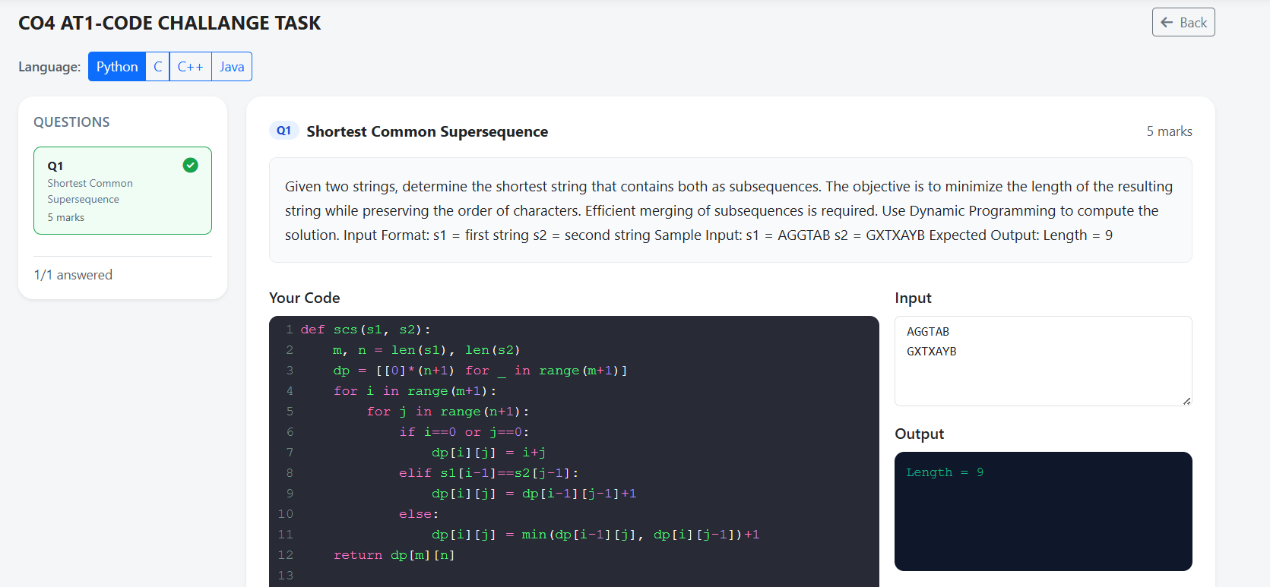

Shortest Common Supersequence Using Dynamic Programming
Problem Statement
Given two strings S1 and S2, find the length of the shortest string that contains both strings as subsequences while maintaining the original order of characters.
Sample Input:
S1 = AGGTAB
S2 = GXTXAYB
Expected Output:
Shortest Common Supersequence Length = 9
Time Complexity
The algorithm uses two nested loops.
- Outer loop executes m times.
- Inner loop executes n times.
Therefore,
Time Complexity = O(m × n)
For strings of approximately equal length n:
Time Complexity = O(n²)
Space Complexity
A two-dimensional DP table of size (m+1) × (n+1) is maintained.
Therefore,
Space Complexity = O(m × n)
For strings of approximately equal length:
Space Complexity = O(n²)
Approach
Dynamic Programming is used to calculate the Shortest Common Supersequence.
Let:
- m = length of string S1
- n = length of string S2
- dp[i][j] = length of the shortest common supersequence of the first i characters of S1 and first j characters of S2.
RESULT
Thus, the Shortest Common Supersequence problem is solved efficiently using Dynamic Programming. For the given strings AGGTAB and GXTXAYB, the minimum supersequence length obtained is 9.

